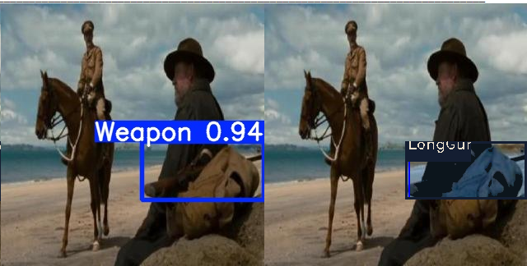 | LongGun
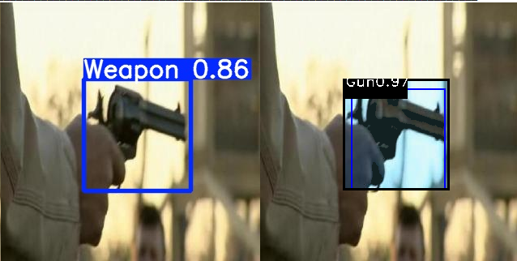 | Gun  & Enhance Localization
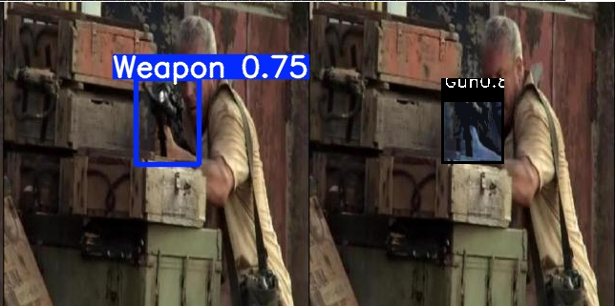 | Miss classify by 2nd stage
- Sample detections of proposed model on our “Weapon” dataset. We assume any missing classification is not counted as actual miss and is counted as weapon hit)

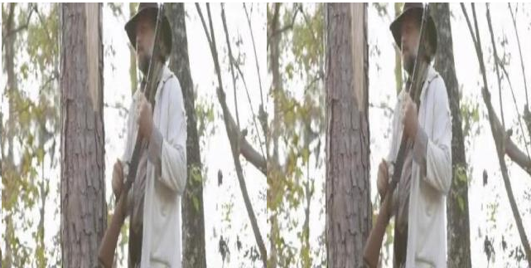 | YOLO missing detection
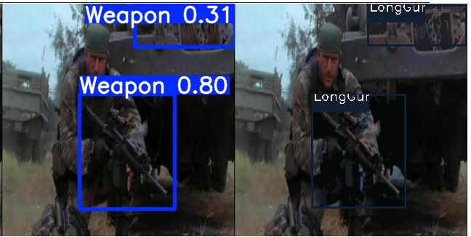 | Two stages false-positive (detection of confidence 0.31)
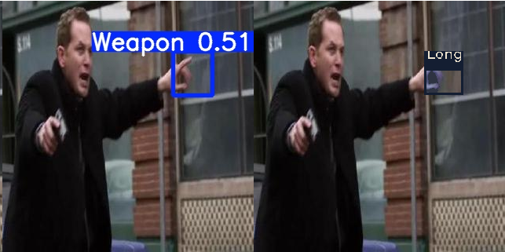 | YOLO missing and two stages false-positive
- Sample error patterns by proposed model on “weapon” dataset
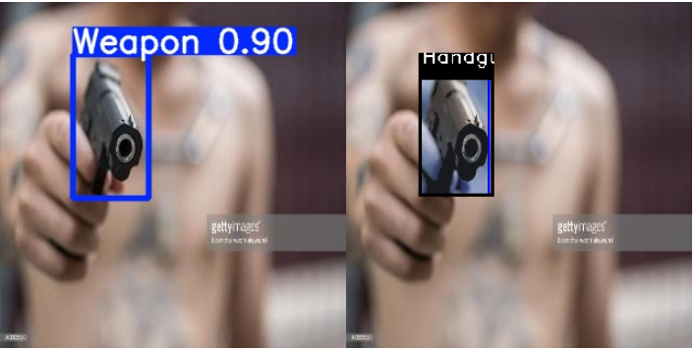 | Handgun
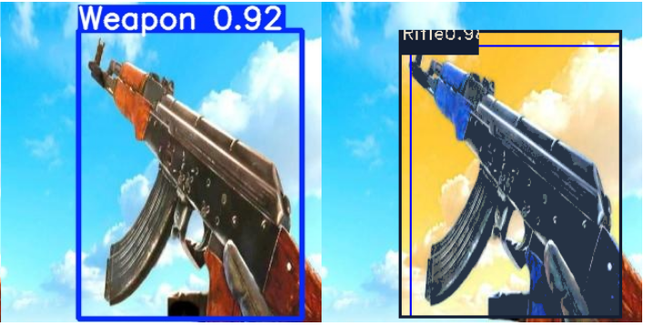 | Rifle
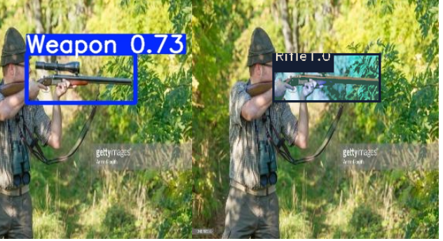 | Rifle
- Sample detection of proposed model on “weapon classification” reference dataset. Detections of different classes are shown as second stage output after passed by first satge as one class “weapon”

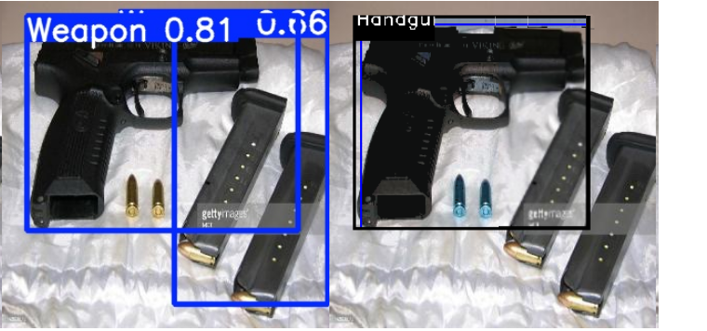 | YOLO false-positive detection (detection of confidence 0.66), rejected by classifier
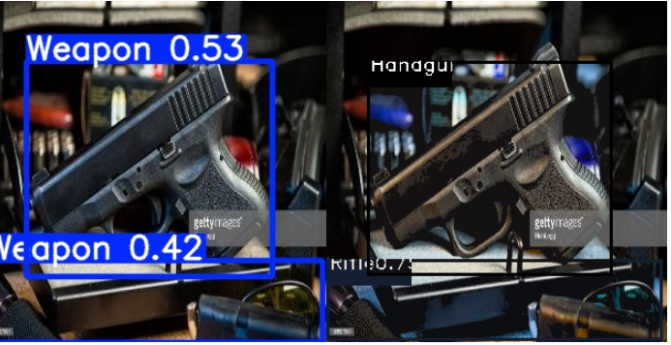 | YOLO false-positive (detection of confidence 0.42), accepted by classifier
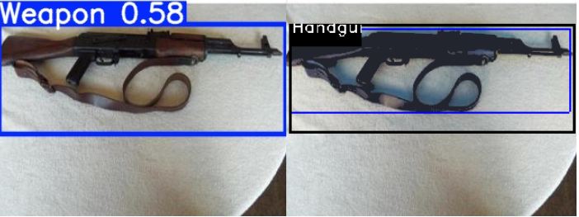 | Miss classify by 2nd stage
- Sample error patterns by proposed model on “weapon classification” reference dataset

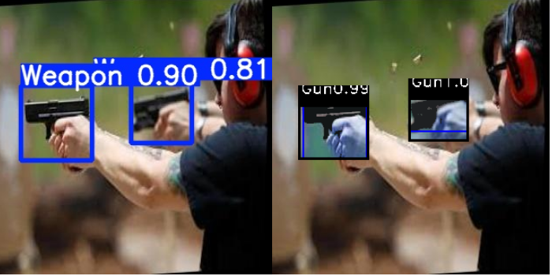 | Gun
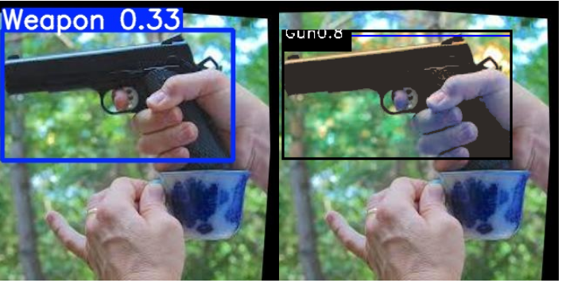 | Gun
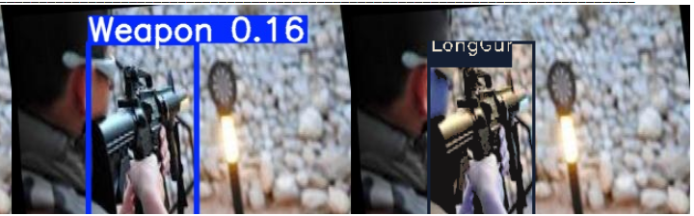 | LongGun
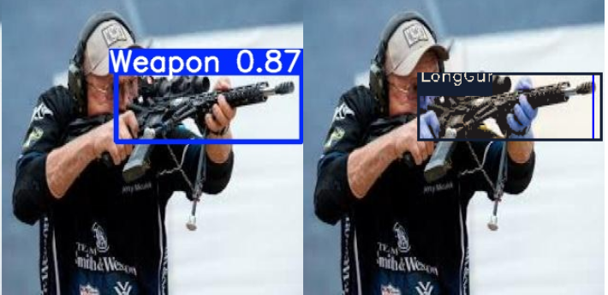 | LongGun
- Sample of detections with re-localization
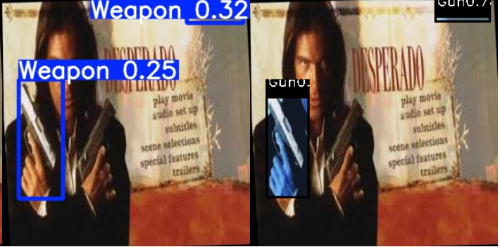 | Missing Gun by 1st stage and FP not rejected by 2nd stage
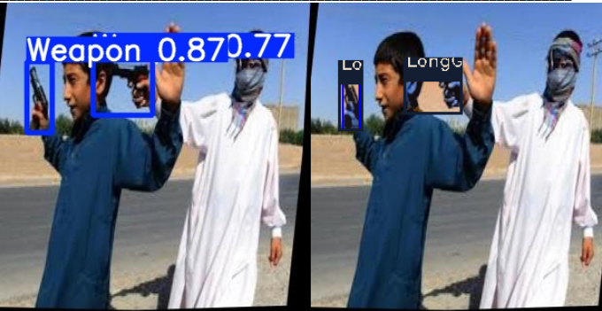 | Miss classify by 2nd stage
- Sample errors of missings or false-positive detections
- Sample detection of proposed model on footage dataset. Detections of different classes are shown as second stage output after passed by first satge as one class “weapon”

